Community Building: 1st Grade
Explain
Evaluate
Elaborate
Explore
Engage
E

Engage with Books:
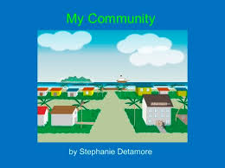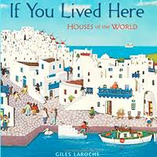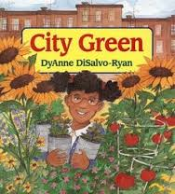
Engage with Media:
What makes a good community
Kids Discuss What a Community Is
Community Helpers

S- Green Earth
T- 3D Printing
E-Designing their Community
A-Drawing their Community
M- shapes

Curriculum Connections:

Summarize ways that humans protect their environment and/or improve conditions for the growth of the plants and animals that live there (e.g., reuse or recycle products to avoid littering).

1.1.G Use geographic representations, terms and technologies to process information from a spatial perspective.
1.1.G.2 Give examples showing the location of places (home, classroom, school and community).

1.G.2 Compose two-dimensional shapes (rectangles, squares, trapezoids, triangles, half-circles, and quarter-circles) or three-dimensional shapes (cubes, right rectangular prisms, right circular cones, and right circular cylinders) to create a composite shape, and compose new shapes from the composite shape. (Note: Students do not need to learn formal names such as “right rectangular prism.”)

Vocabulary: community, recycle, 3D, cube, cylinders,
I Can Statements:
I Can explain what a community is
I Can explain how humans protect our environment
I Can give examples of what belongs in a community
I Can identify 3D shapes such as cubes, rectangles, squares
E

First Day: Engage ( see above under engage)
Have students brainstorm what kind of buildings would be in a community
How can we make our community protect our environment
Put students in groups and have them think of what they would like to 3D print for their community. Examples: firestation, police station, hospital, and houses.
E

Second Day: Explore: See Task Cards: ( Have kids go to each station in their groups from the previous week)
- Have students go and use the challenge cards to explore the site below:
www.tinkercad.com ( You should have your account signed in on 3 computers
- Have 3D shapes or wooden blocks around the table. Have students identify the shapes of the 3D blocks with the label cards. Have them draw the shape and label it on the wipe-off laminated cards.
- Draw what you would like your building to look like in your community using shapes
- Watch the videos on ways we can protect our environment
- Design and build a community with your group using blocks
E

Third Day: Explain
Ask students what 3D means.
Set-up computers so that each group has two per group. Have www.tinkercad.com set up under your username and password. Have students make their building using the shapes.
Teacher must work with with each group for 10 minutes.
Have students draw and map out where they want to place buildings in their community

Fourth Day: Elaborate:
Students watch their building being printed.
Students design a map and place their community on cardboard.

Product:
A 3D printed Community
E

Evaluation: Students

Some groups may need to come in the morning to print. Try to have a group print each time you have a class.

